SD007 – REPORTING DESIGN SOP

Date of Creation: | 01/06/2024 | Frequency of Update: | Biennial
Last Review Date: | 07/08/2025 | Next Review Date | 07/08/2027
Document Reference: | SD007 | Version Number: | 1.1
Original Author: | Dev Chadha
Review Author: | Esme Jungius
Consulted: | N/A
Authorised by and date:
Date Effective from: | 28/08/2025

1.0 Purpose
2.0 Scope
3.0 References and Related Documents
4.0 Definitions
5.0 Roles and Responsibilities
6.0 Procedure
7.0 Appendices
8.0 Revision History

- Purpose
To ensure that dashboard reports for a service are designed and created by following the same principles. Having a process in place for creation of reports allows the service design and business intelligence (BI) teams to work efficiently to create reports that are:

In scope – have been agreed with the internal project team and client (where relevant) and therefore costed in. Working on out-of-scope documents introduces risk and loss into the service design process.

Fit their brief – deliver on what has been agreed for the service

Follow a consistent and standard format wherever possible – using an existing report as a template may help to increase efficiencies in the time taken to design a report for a new or updated service. The template may be from an existing service in the same therapy area and/or an existing service for the same client that is already in the client’s preferred style/format.

Accurately report aggregated review data – processes are followed which ensure that dashboard reports leverage the correct data within the CLIICS database and perform the correct processing to derive the desired reporting outcomes. Design and testing procedures are in place to ensure accurate data reporting

2.0 Scope

This procedure applies to all members of the service design team when designing a new report. Examples of the types of reports required for a service can be found in 7.1 Example list of reports required for a service.

3.0 References and Related Documents
Further detail on specific reports required for a service can be found in the service schedule.

Service schedules are found in the Teams channel for a project/service. Please contact the Compliance and Medical Affairs lead for the project/service if you are unable to find the service schedule or to confirm you are using the current version.

SD004 Service schedule SOP details how to create/review a service schedule and how to amend one if you notice an error or omission which may occur when you are referring to a service schedule to create a report.

4.0 Definitions
BI – Business Informatics team
Service schedule – list of materials required for a project/service.

5.0 Roles and Responsibilities

Role | Responsibilities
Head of Clinical Services | Accountable for this procedure
Service Design Manager | Maintaining this procedure, Training new team members on this procedure
Technical Design Manager | Training new team members on this procedure
Service Design team | Following this procedure

6.0 Procedure
6.1 Establish whether the document you have been asked to create is within scope by reviewing the service schedule.

In scope: If the document is listed in the service schedule and marked as required, continue following this procedure to create the document.
Out of scope or uncertain whether in scope: If the report is not listed, marked as not required, or you have any doubt as to the accuracy of the service schedule and/or requirement of the report for the service (e.g. change to proposed service or scope following discussion with the client or internal discussion), consult with the Service Design team lead for the service and/or other internal service leads (e.g. Compliance and Medical Affairs, National Account Manager, Project Management Office).

6.2 Confirm you have a clear understanding of the report you are to create: review its entry in the service schedule (7.2 Sample service schedule headers to show the information contained within a service schedule), refer to relevant notes from internal/client discussions about the report. Seek clarification if you are unclear of the brief.

6.3 Confirm whether there is an existing report and/or service that is to be used as a template for the new report you are creating. Refer to the Service Design team lead and/or other internal service leads if you are unsure.

6.4 If using an existing report as a template, adapt it to fit the brief for the new service. Refer to documents already certified for the new service to make sure the formatting and standard content for the service (such as a funding statement) are consistent.

6.5 When designing a new report, produce a draft storyboard and share it as soon as possible with other members of the Service Design team (e.g. within the MS Teams channel for the service). Giving the project team early visibility and opportunity to review ensures that the proposed content is agreed internally before time is spent producing something to approval/finished standard that then requires extensive amends. Once the content/draft storyboard has been agreed, proceed to bring the report up to final standard. Refer to documents/reports already certified for the service to make sure the formatting and standard content for the service (such as a funding statement) are consistent.

6.6 Share the final version of the report for final internal review before confirming with the Compliance & Medical affairs lead for the service that the report may be submitted to client (where applicable).

6.7 Once Compliance & Medical Affairs lead has confirmed that the report is certified, they share the certified version with the Service Design and BI email groups so that BI can programme the report such that it may be produced via CLIICS.

6.8 Accuracy check by SD and Compliance.

6.9 Accuracy check of data and logic.

6.10 Order of reports creation baseline>outcomes>LHE.

For a schematic of the dashboard build and QC process please see Appendix 7.3.

7.0 Appendices

7.1 Example list of reports required for a service

Reporting
Practice baseline report
Practice outcomes report (individual site)
LHE outcomes report (aggregate)
Evaluation Report

7.2 Sample service schedule headers to show the information contained within a service schedule
Material
Target audience
End User
Description/Objective
Required (Y/N)
Team responsible for creation
Person(s) assigned
Comments
Document Type (e.g. PDF, spreadsheet, email)
Job Bag No
Date of preparation
Submission to client deadline
Date first submitted to client
Client review deadline
Current Review Status
Date Approved for Use
Who to notify once approved
Action following approval to make live SEE "ACTIONS TO MAKE LIVE TAB" and SOP
All actions completed and document live? SEE "ACTIONS TO MAKE LIVE TAB" and SOP Y/N
Review date

7.3 Dashboard production and QC process flow

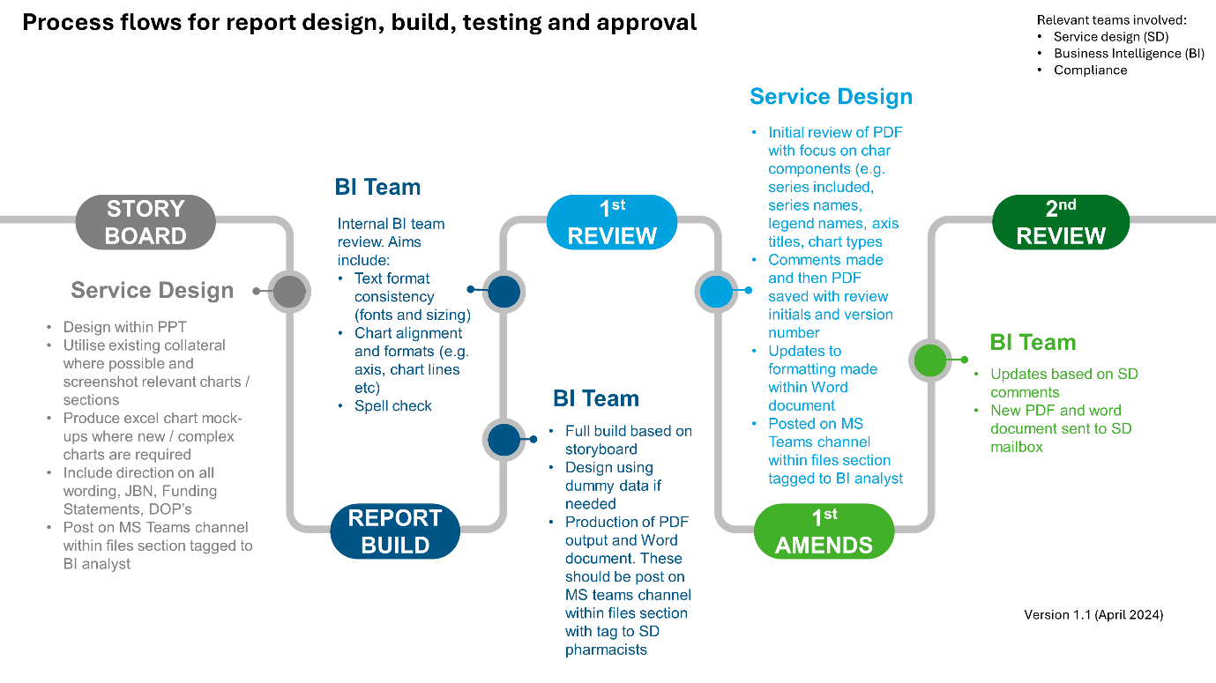
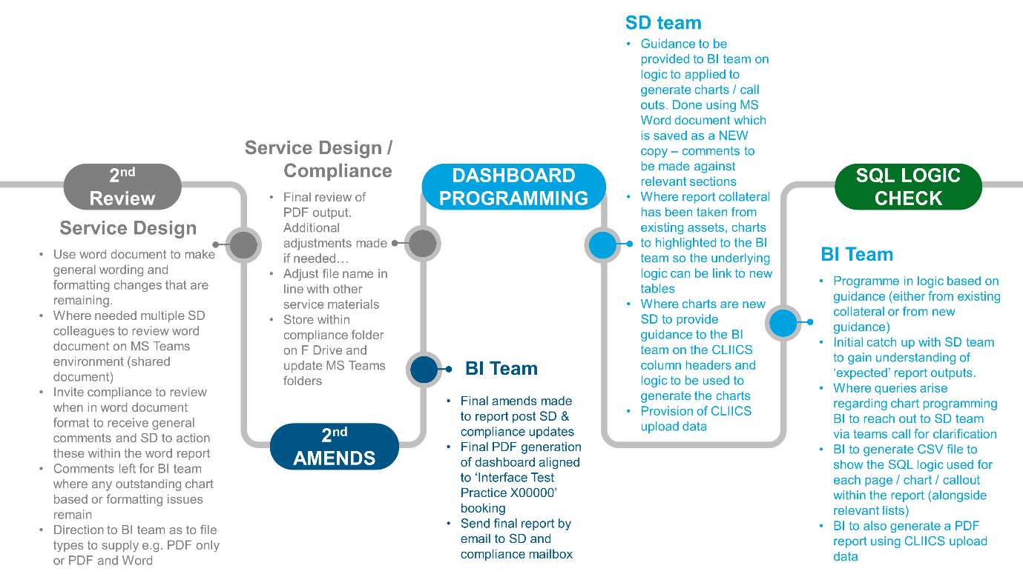

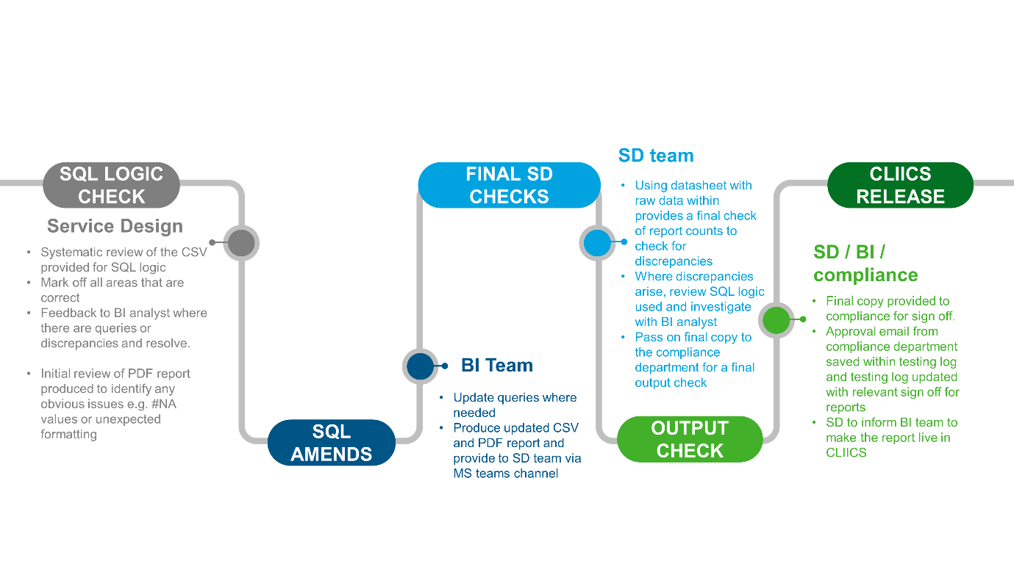

8.0 Revision History

Date | Change | Version | Author
June 2024 | Document creation | 1.0 | Dev Chadha
Aug 2025 | Annual review – review frequency changed from annual to biennial | 1.1 | Esme Jungius

